**Software Requirements Specification**

**for**

**Online Human Resource Management System**

**Version 2.0 approved**

**Prepared by Somay Das**

**Techno Main Salt Lake**

**15-10-2022**

**Table of Content**

1. **Introduction**
   1. **Purpose/Objective**

This document aims to give a brief description about the HR Management System Project. With the help of this document the needs of the company and the solution that will be provided to that needs will be clearly presented. In other words this document will provide a basis for validation and verification.

* 1. **Document Conventions**

1.2.1 Alignment

The entire document is in justified alignment.

1.2.2 Convention for the Main Title

1.2.2.1 Font Face: Times New Roman

1.2.2.2 Font Style: Bold

1.2.2.3 Font Size: 24

1.2.3 Convention for the Sub Title

1.2.3.1 Font Face: Times New Roman

1.2.3.2 Font Style: Bold

1.2.3.3 Font Size: 18

1.2.4 Convention for the Body

1.2.4.1 Font Face: Times New Roman

1.2.4.2 Font Size: 12

1.2.5 Abbreviations:

* SRS: Software Requirements Specification
* HRMS: Human Resource Management System
* HR: Human Resource
  1. **Scope**

This document covers the whole definition of the HR Management System (HRMS) project. It basically includes the requirements for managing the personal data, controlling authentication and authorization mechanism, and evaluating employees' performance. After creating the new HRMS

we have to accomplish data migration from their existing system to our new one.

More specifically, our HRMS (HR Management System) controls and manages the personal database such that any user with different role types as manager, admin, employee, and human resource will be able to manipulate their personal data. In addition to manipulating the personal data, our HRMS will provide authentication and authorization mechanisms. Every user with any role type can be able to login to the system with his/her username and password.

* 1. **References**

     2. IEEE Std 830-1998: IEEE Recommended Practice for Software Requirements Specifications
     3. http://www.ibm.com/developerworks/rational/library/769.html
     4. http://www.cs.iusb.edu/thesis/SLingareddy_thesis.pdf
     5. http://en.wikipedia.org/wiki/Eclipse_(software)
     6. <http://www.eclipse.org/org/>

1. **History/Background Study** 
   1. **Technical Literature**

The human resources field began to take shape in 19th century Europe. It built on a simple idea by [Robert Owen](https://en.wikipedia.org/wiki/Robert_Owen) (1771-1858) and [Charles Babbage](https://en.wikipedia.org/wiki/Charles_Babbage) (1791-1871) during the [industrial revolution](https://en.wikipedia.org/wiki/Industrial_revolution). These men concluded that people were crucial to the success of an [organization](https://en.wikipedia.org/wiki/Organization). They expressed the thought that the well-being of employees led to perfect work; without healthy workers, the organization would not survive. HR emerged as a specific field in the early 20th century, influenced by [Frederick Winslow Taylor](https://en.wikipedia.org/wiki/Frederick_Winslow_Taylor) (1856–1915). Taylor explored what he termed "[scientific management](https://en.wikipedia.org/wiki/Scientific_management)" (sometimes referred to as "Taylorism"), striving to improve economic efficiency in manufacturing jobs. He eventually focused on one of the principal inputs into the manufacturing process—labor—sparking inquiry into workforce productivity.

* 1. **Existing Applications**
     1. LinkedIn
     2. Human Research Magazine SHRM
     3. Quizlet
     4. HR Management App
     5. Trello
     6. Coggle
     7. Rescue Time
     8. Microsoft To Do
  2. **Customer Surveys**

[https://docs.google.com/forms/d/1VEKVXgq7yy- Othi35ZGeSAAsiGTym3uVgtpF-NluLaA/edit#responses](https://docs.google.com/forms/d/1VEKVXgq7yy-)

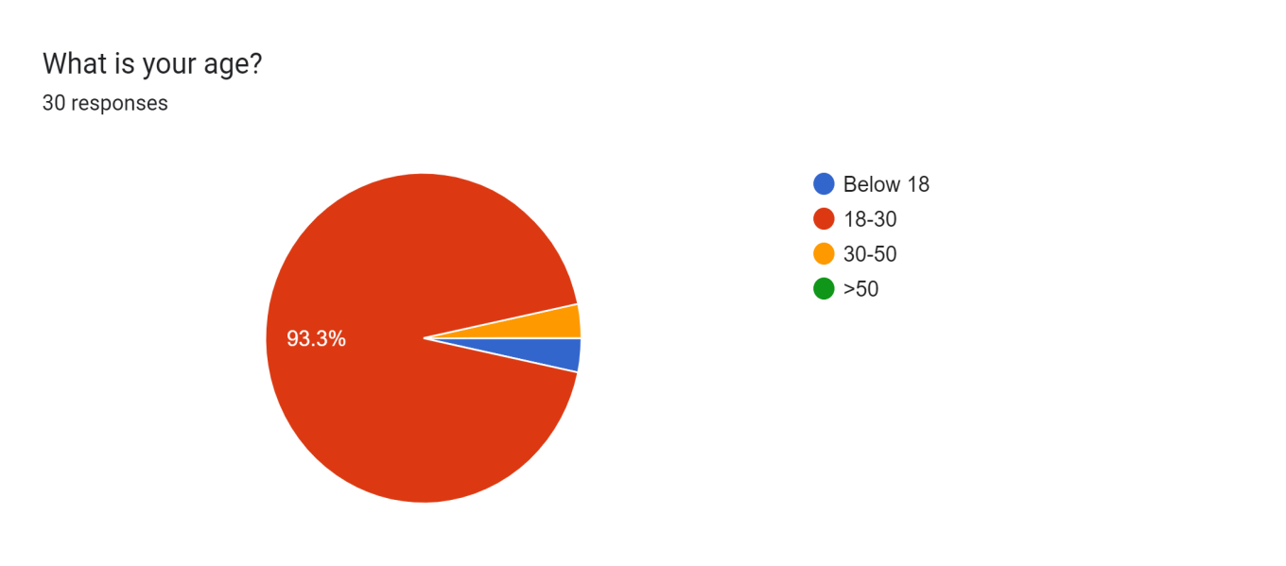

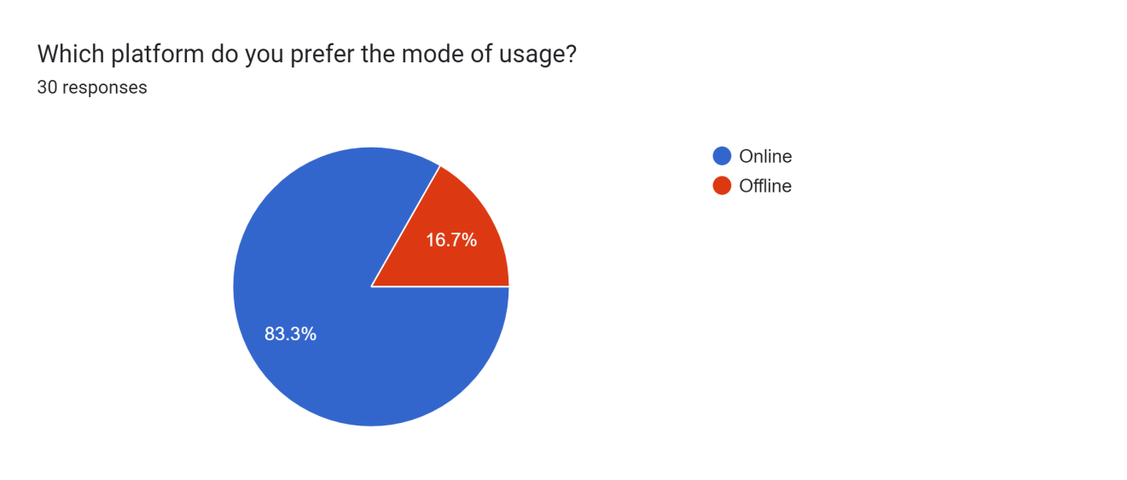

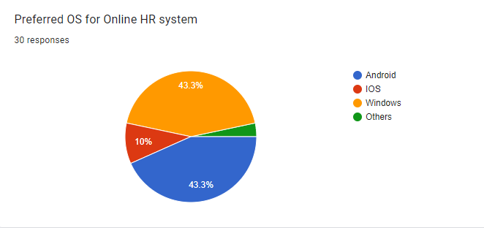

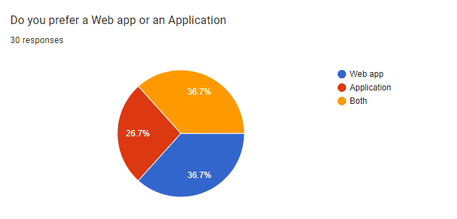

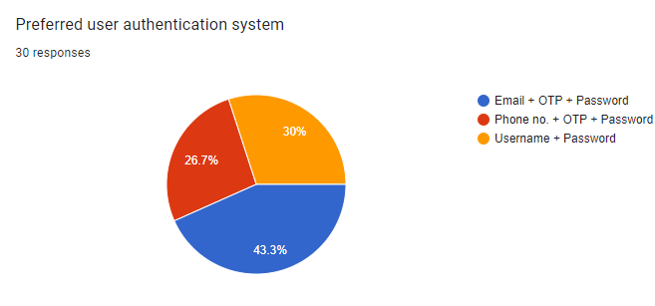

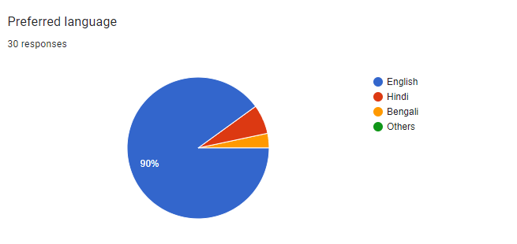

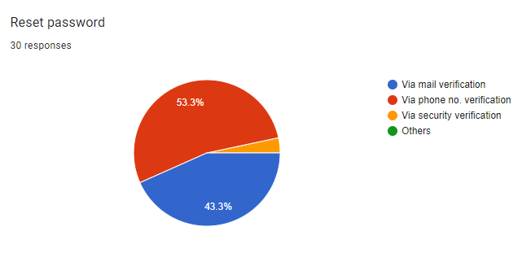

* 1. **Expert Advice**

The application is the best and most affordable way to manage the employees in the office . The application support News posting facility and private message setting with a considerable amount of security.

* 1. **Current/Future requirements**
     1. One centralized database rather than multiple databases, which can happen when the software is built through acquisitions.
     2. All the necessary employee information can be entered, such as employee name, address, emergency contacts, salary, job and department.
     3. Ability to create custom fields to track information specific to the organization.
     4. Role-based security, which simplifies the assignment of access rights to employees.
     5. Future-dated and back-dated changes are entered.
     6. System is configured to meet all government compliance requirements and the required data extracted.
     7. Non-employee data, such as contractor information, can be entered.

1. **Overall Description**
   1. **Product Functions**
      1. **Hardware Requirement**
         1. A device (Computer/ laptop/ android/ ios) with at least 2 GB RAM
         2. Hard disk space required - 250 MB
         3. Minimum snapdragon 600 series/ i3 8th gen/ apple all bionic
      2. **Software Requirement**
         1. Since HRMS application is a web-based application, internet connection must be established.
         2. The HRMS software will be used on PCs and will function via internet or interanet in any web browser.
         3. The HRMS application interface will be developed by Java (J2EE) framework.s
         4. The HRMS software will support JDK environment.
         5. The HRMS software personal database model will support MYSQL environment as DBMS.
         6. The HRMS will run on any platform supporint JDK technology.
         7. Application will run on 256MB or higher of RAM.
   2. **Functional Requirements**
      1. **Login**
         1. **Existing User**

Input: Enter the employee id and passcode

Output: Entering into the body

* + - 1. **New User**
         1. Provide the registered code sent on your approval of joining.
      2. **Sign Up for New User**
         1. Input

Enter your basic credentials

Enter your family dependencies

Provide the passcode you want to use

* + - * 1. Output

A confirmation page will appear asking to recheck all the credentials validation

An unique employee id will be provided which will be later he/she will have to use while login.

* + - 1. **Login Failure**
         1. If the user does not exist in the database or the user did not get authorized by the HRMS admin yet.
    1. **Payroll Enquiry**
       1. **Basic Salary** 
          1. The amount to be credited each month will be displayed
       2. **Various Duty Allowance**
          1. Monthly allowance paid in addition to basic salary for carrying out duties in excess of a participant's substantive office where an acting allowance cannot be paid will be updated at once.
       3. **Incentives**
          1. As per your working performance points table will be updating , and thus at the end of the quarter of the month incentives will be calculated with the salary.
    2. **Insurance Enquiry**
       1. **Life Insurance**
          1. The employee can check the details by visiting this page.
       2. **Health Insurance**
          1. The employee can check the details by visiting this page
       3. **Wellness Programs**
          1. Various programmes regarding the health and workout related will be posted.
       4. **Coupons**
          1. The points the employee did earn in the incentive table, can be used for unlocking various membership cards and coupons.
       5. **Mediclaim**
          1. Upload the prescription and drug bill for up to 80% cashback.
       6. **Vehicle Insurance**
          1. The employee can apply for car/bike insurance and can thoroughly study it for future concerns.

* + 1. **Authorization Enquiry**
       1. **User role check**
          1. After logging in, the user role will be checked from the database and the user interface will be created according to that role.
    2. **Recruitments**
       1. **Full time Employment**
          1. **Job Details**

This segment provides all details regarding the job an IT specialist wants to pursue and serve the organization.

* + - * 1. **Hiring Process**

A newbie must go through the hiring process before and subsequently needs to qualify all needs.

* + - 1. **Internships**
         1. **Internship Enquiry**

A college student is eligible to enquire about the internship provided in the organization.

* + - * 1. **Intervening process**

He/She needs to sit for an interview round.

* + 1. **Employee Welfare Enquiry**
       1. This segment provides various details about cultural events and subordinating panels to build a healthy environment supporting the welfare of the human resource.
    2. **Employee IR Issue**
       1. **Rules and Regulation Enquiry**
          1. An employee can visit about all the rules and regulations concerning them.
       2. **Labor Category Enquiry**
          1. A tree of the employee is provided for explaining the whole human resource structure upon which the system relies.
       3. **Industrial Relation**
          1. **Disobey**

On disobeying, HR can take action on the respective employee and proceedings for future circumstances are expected at immediate succession at this section.

* + - * 1. **Behavioral Issue**

HR needs to manage the matter, and each such circulars will be taken care of.

* + - 1. **Issue Registration**
         1. An employee can register any IT/others related statements in this section which will later be resolved.
    1. **Process Data**
       1. **Display**

Users with defined roles can display the content of the database. Being more specific, an employee can only view his/her personal information.Manager can see not only his/her personal information but also employees’ information who are working under his /her coverage.Admin and HR can display their personal information and all employees’ information.

* + - 1. **Edit**

A user with employee role can edit his/her specific personal information. Manager can only edit employees’ personal information that is under his/her coverage except user role type. HR can edit all employees’ information except user role type. Admin can edit all information related to all employees’ including their user role type.

* + - 1. **Search**

Employees who are under his/her coverage. HR and

admin roles can search all the employees’ information in the database. Search feature works on specific keywords showing employees’ characteristics, peculiarities, skills, features, and etc. For example, HR wants to find employees who are well trained in “Java Programming Language”. He/she will write the specific keyword in the search bar and press available search button. Afterwards, he/she will find a list of all the employees’ who know “Java Programming Language”.

* + - 1. **Report**

This feature is basically used to filter the contents of the search mechanism. For instance, as we mentioned in the above search feature. The HR wants to get a report of some specific employees who know “java programming Language”. The list of employees obtained from the result of search feature he/she can get the specific report by selecting the corresponding checkbox available for each employee. Or a manager role type can get a report of some or all employees’ who are working under his/her coverage by selecting the checkbox. Except employee role type, all other role types such as admin, HR, and manager can use this feature.

* + - 1. **Update authentication**

This feature can be used only by admin role type. Admin can update the role type of a specific user. For example, an employee got promotion

and his role type will be changed from employee role to manager role.

Admin will be able to update this authentication mechanism.

* 1. **Non-Functional Requirements**
     1. **Correctness Requirement**

All the different requirements specified in the document have been correctly implemented. It covers all the requirements that are expected from the Online HR Management Portal.

* + 1. **Portability requirement**

The application is XML and programming language based. So that the end-user part is fully portable and any system using any web browser should be able to use the features of the system, including any hardware platform that is available or will be available in the future. An end-user uses this system on any OS; either it is Windows or LINUX. The system shall run on PC, Laptops, Mobile, etc.

* + 1. **Efficiency Requirement**

The software is highly efficient and various tasks in its various modules simultaneously. Even if the system fails, the system will be recovered back up within an hour or less.

* + 1. **Usability Requirement**

The software has a simple but efficient user interface, which can be used by all types of users, both technically sound as well as people not having so much technology knowledge. So, any user can use its functionalities without any sort of complications.

* + 1. **Reusability Requirement**

The system should be available at all times, meaning the user can access it using a web browser, only restricted by the downtime of the server on which the system runs. In case of a hardware failure or database corruption, backups of the database should be retrieved from the server and saved by the administrator. Then the service will be restarted. It means 24 X 7 availability.

* + 1. **Reliability Requirement**

The system provides storage of all databases on redundant computers with automatic switch over. The reliability of the overall program depends on the reliability of the separate components. The main pillar of reliability of the system is the backup of the database which is continuously maintained and updated to reflect the most recent changes. Thus all overall stability of the system depends on the stability of the container and its underlying operating system.

* + 1. **Maintainability Requirement**

A commercial database is used for maintaining the database and the application server takes care of the site. In case of failure, a re-initialization of the program will be done. Also, the software design is being done with modularity in mind so that its maintainability can be done efficiently.

* 1. **User Characteristics**

The application does not require any specific computer knowledge to use it except the developers and administrators of it. On the other hand, administrators and potential developers need a high level of expertise to understand web technologies.

* 1. **Design & Implementation Constraints**

Any update regarding the article will have to be recorded and the correct information must be updated and all the cost calculations must be done as soon as possible. The backup of all the data must be done on a hard disk. There are not so many strong firewalls so proper antivirus scans must be done before use. There is no provision for saving incomplete data.

* 1. **Assumptions & Dependencies**
     1. **Assumptions**
        1. Coding is error-free.
        2. The system should have an apt storage capacity and provide fast access.
        3. Users must use their username and correct passwords.
     2. **Dependencies**
        1. The product needs the following third-party
        2. applications for the development of the project:
           1. Android Studio
           2. Netbeans
           3. UI/ UX(editing layouts, icons, buttons,etc.)
        3. Being a social network website, the software should ensure the safety of information given by the user and provide some privacy setting options to the user. It cannot sell the private information of users to someone else but if the user permits an application can access some information of the user.

1. **Interface Requirements**
   1. **User Interfaces**

All the users will see the same page when they enter HRMS. This page asks the users a username and a password. After being authenticated users will see the interface containing the information of the first tab of the user role types. This interface include different tabs according to their role types determined by

admin at the authentication phase. By the way, users may have more than one role. Then a user who has more than one role will be able to see all the tabs that are related to his/her role types. These tabs can be named as; Personal Data Tab, Employee List Tab, Add New Employee Tab, Add New User Tab, Manage Users Tab, Users List Tab and Arrange Roles Tab. User who have employee role have authorization to see only Personal Data Tab, HR role gives right to see Employee List Tab and Add New Employee Tab. Manager role gives authorization to seeonly Manager Tab. And Admin role gives user right to see User List Tab and Arrange Roles Tab. These authorizations are default ones but an admin can change these authorizations by Arrange Roles Tab.

* 1. **Hardware Interfaces**

The system must run over the internet, all the hardware shall be required to

connect to the internet.

a. WAN - LAN Network

b. Ethernet Cross-Cable

c. Modem

* 1. **Software Interfaces**

The system is on the server so it requires any scripting language PHP, VBScript etc. The system requires a Database also to store any transaction of the system like MYSQL, etc. system also requires DNS (Domain Name Space) for the naming of the internet. At the last user needs a web browser to interact with the system.

* 1. **Communication Interfaces**

As a whole management website, we will be a completely stand-alone system that lets other platforms connect, fetch and transform data at certain levels. The platform will provide APIs and tools for third-party developers to let them create high-level integrated plugins and programs. The main communication interface with the other platforms will be the application . However, this integration and its level will be set by the user, who wants to integrate their accounts and information with other websites.

1. **Conclusion**

This document states the design level approach taken for the project HRMS. After giving a basic information about what the HRMS is, the document briefly describes the problem and the solution we proposed to the problem with the figures to visualize better and steps taken to solve the problem. In other words this document introduces the technical details of the HRMS.

In the first part of the technical design, the major functions needed to develop an HRMS are introduced. Later on, these major functions and their sub-functions are visualized with the use case diagrams. In the second part, user interfaces are described in a detailed manner with figures. Lastly,data modules and their relationships are discussed.To conclude, this document constitutes a base for the development of an HRMS.